# Requirements Document PSA-TCO System

Author: Gabe De Mesa

Latest Revision: 5//14/2020

State: Ready for review

Requirements Document PSA-TCO System

Executive Summary

Background

Problem Motivation

Key Definitions

Potential Impact

Application Context / Environmental Constraints

Critical Use Cases

Feature Inventory

User Permissions:

Software Quality and Non-Functional Requirements

Assumptions / Risks

Deployment Plan

Privacy

Open Issues

## Executive Summary

Pacific States Aviation is (PSA) in need of a cohesive software application where flight instructors, students, and administrators can access different syllabi (Private, Commercial, etc.) Currently, PSA is using a legacy hand-written method to document and track students’ progress throughout their time training and learning the skills to become a pilot. The value of the online syllabi tracker system is to help keep better track of their recorded flight hours which is necessary to graduating pilots and vital to getting a job in the industry. Considering the volume of current and future students, the application will resolve older techniques of hand-writing tracking lessons and will improve the efficiency, and ease of intake and graduation of all future and current students within the PSA training program.

## Background

The Syllabus Tracking System (PSA-TCO) is being implemented for Pacific States Aviation (PSA) est. 1946. As an international brand for providing flight training to pilots, PSA wants the app to support a multitude of different types of syllabi with emphasis on simplicity, ease of access, and flexibility. PSA requires round-the-clock access secure access in order to provide access to the syllabus tracking system. Additionally, PSA needs to have 24/7 support to fixing any bugs, security vulnerabilities, glitches, etc.

### Problem Motivation

PSA’s incentive for creating the syllabus app is derived from a history of filling in hand-written paper logs and lessons. Additionally, issues would arise when updating or adding any new syllabi. Furthermore, it is hard to keep track of current paper trails when it is easy to lose and keep track of increasing logs, syllabi, lessons, etc. Additionally, keeping track of dates and spelling are prone to errors since there are no automated ways to implement error checking within the current legacy system.

### Key Definitions

|  |  |
| --- | --- |
| **Term** | **Definition** |
| VFR | Visual Flight Rules |
| IFR | Instrument Flight Rules |
| TCO | Training Course Outline |
| Prototyping | Designing a working first version of the Syllabus Tracker. |
| via | by means of. |
| Scalable | Able to scale, able to grow with increasing demand |
| Syllabi | Plural for syllabuses |
| ALL LICENSES | PPL, IR, CPL, ATP, CFI, CFII, MEI, ME |
| PIC | PILOT IN COMMAND |

### Potential Impact

This application will allow all users at Pacific States Aviation to be able to have a centralized system of managing/editing syllabi, tracking student flight records and lessons, and establishing an electronic paper trail for recorded flights as well as providing access to a student’s certifications and information. This impact of this software will completely revolutionize how instructors conduct grading, students sign and study for their lessons, and streamline audits that will be performed by the FAA.

## Application Context / Environmental Constraints

The application will run on a network of servers and should be able to be accessible anywhere at any time around the globe. The system can handle at most 1000 users at a time. System should be able to integrate with MacOS, Windows, and should be able to work with popular browsers like Chrome, Safari, and even Internet Explorer and Edge.

## Critical Use Cases

Students and Instructors will be able to sign and view their syllabuses 24/7 anywhere around the world. Instructors will be able to grade lessons and add to students’ chronologs.

## Feature Inventory

|  |  |  |
| --- | --- | --- |
| Feature | Use Case | Feature Description |
| 24/7 Access to Syllabus | View | With the availability of 24/7 access to a student’s syllabus,   * Students will be able to view and sign their current syllabus * Instructors will be able to do above and edit lessons which allow students to proceed to the next lesson * Admin will be able to do above, and create lessons, add students, add syllabi, remove lessons, remove students, remove syllabi, and manually allow students to proceed to a future lesson. |
| Flight Lesson Tracking | Edit | An online checklist that documents and timestamps every lesson at PSA. The checklist will provide an overview of the lesson as well as the specific performance of an individual student from that in-person lesson. Lesson grades range from [1-5]. 5 being the worst, and 1 being the best. Students must receive a 4 or higher on all of the grading criteria or will not be able to a future lesson without manual authorization. Lessons will be available for unlimited attempts and logs/timestamps all attempts. Additionally, students and instructors will need to electronically sign the syllabus in order to proceed to a future lesson.   * Students will be able to sign and view their current attempt for a current lesson * Instructors will be able to view, edit, and sign lessons. Additionally, instructors will be able to grade a current student based on a [1-5] scale. Students can sign on an instructor portal by being prompted for their credentials. * Admin will be able to do all of the above and manually override a student to pass a specific lesson or unlock a given lesson for a student. |
| Chronolog  [Timesheet] | Time tracking | This log keeps track of all attempts and records all the hours of a given lesson. The hours and attempts automatically are transferred onto this specific sheet. The total recorded flight time is added up automatically. |
| User Interface | Point and Click | Users will be able to access the application through an easy to use and easy to understand user interface. |
| Login Functionality | Login to the syllabus app with their credentials | Users will need to be added to the database from system admin. Users will automatically be emailed their username and password directly. |
| Database | Store Information | All records, usernames, and passwords are all stored on a private, scalable, secure, and reliable server  [Host TBD] |
| Ground (Commercial) | Take Tests | Students will be able to take a ground training test and their results will automatically be recorded to that specific student. Students will be able to take the test after a specified list of objectives have been completed. Students will be only allowed 2 attempt s and system admin will need to manually allow students more attempts in order to have the student retake the test. |
| Automatic Certification Generation | Graduate and Enroll | Administrators will be able to graduate and enroll students and their certificates will be automatically generated. |

DIAGRAMS

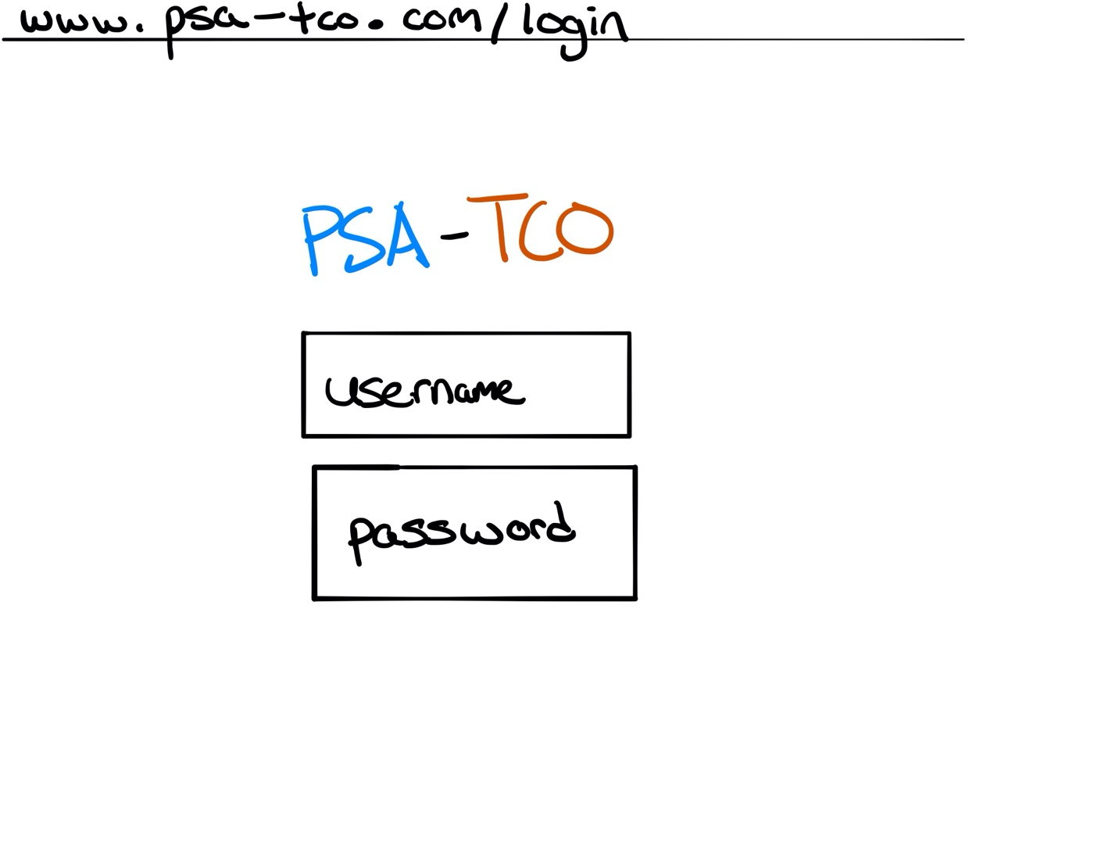

LOGIN SCREEN: Users should have received an email notification w/ their password and email for login. Logins are generated by adding a user as a system admin.

**HOME SCREEN: STUDENT PERSPECTIVE**

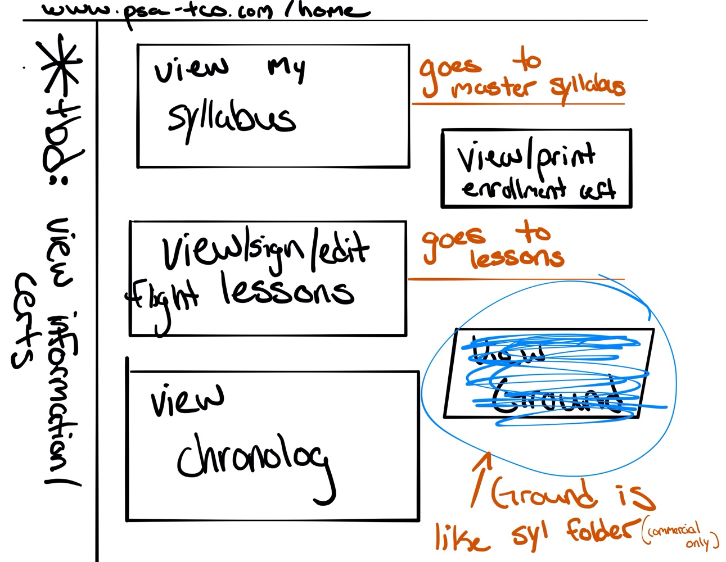

[View My Syllabus]

Students can see the static master syllabus for their license.

[View/Sign/Edit Flight Lessons]

Students will be able to view their lessons (see lessons image below), see which ones are locked/unlocked, sign off on their lessons (either from an instructor account or their own), and grade their own lesson if its PIC (Pilot in Command). Students will not be able to move onto the next lesson unless they finish their current lesson.

Instructors are able to grade any unlocked lessons.

[View Chronolog]

Students will be able to see a log of all their lessons and their total recorded flight time and all their attempts in one place. Students will also be able to print/download their chronolog at any time.

[View Certifications]

Students will be able to view/print their enrollment certification etc. with this button. A new tab will open with a list of their certifications and they can click any one of them.

[TBD My Information]

Students/Instructors/Admin can see their own information i.e. (phone number, name, email). Only admin can change any of this information.

**HOME SCREEN: INSTRUCTOR PERSPECTIVE**

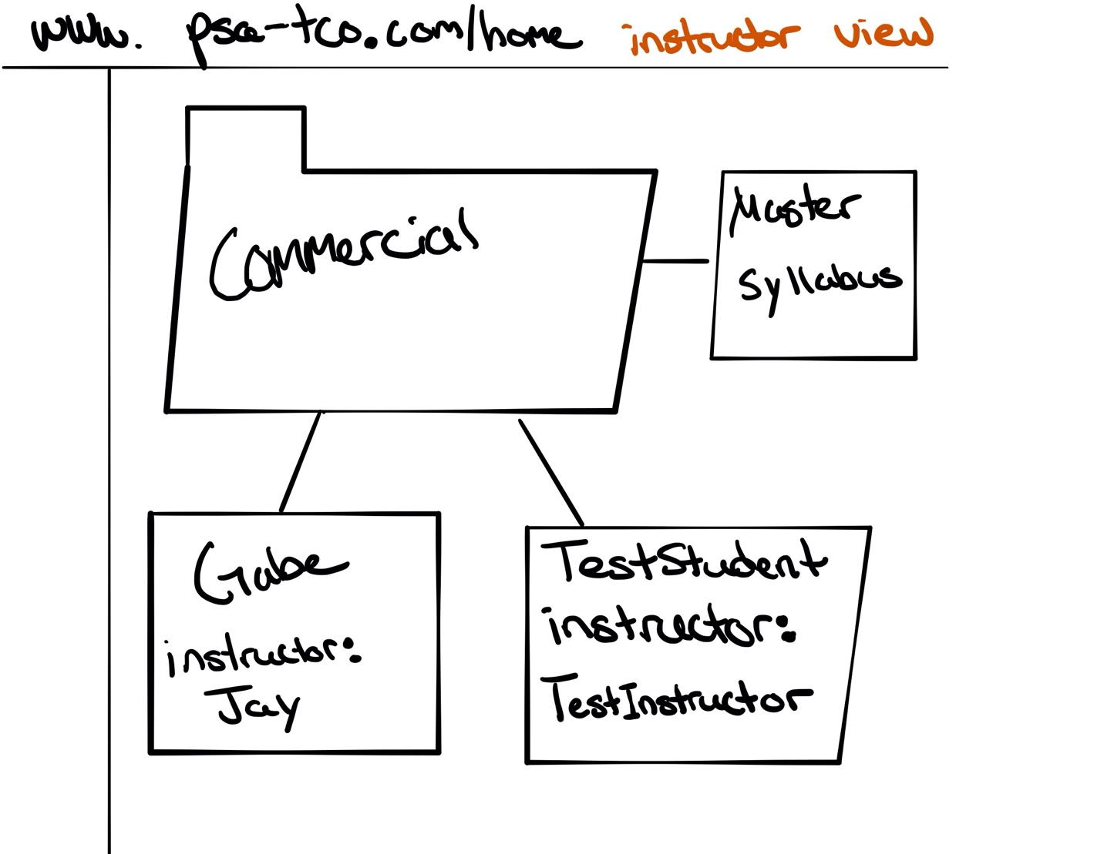

**HOME SCREEN: ADMIN PERSPECTIVE**

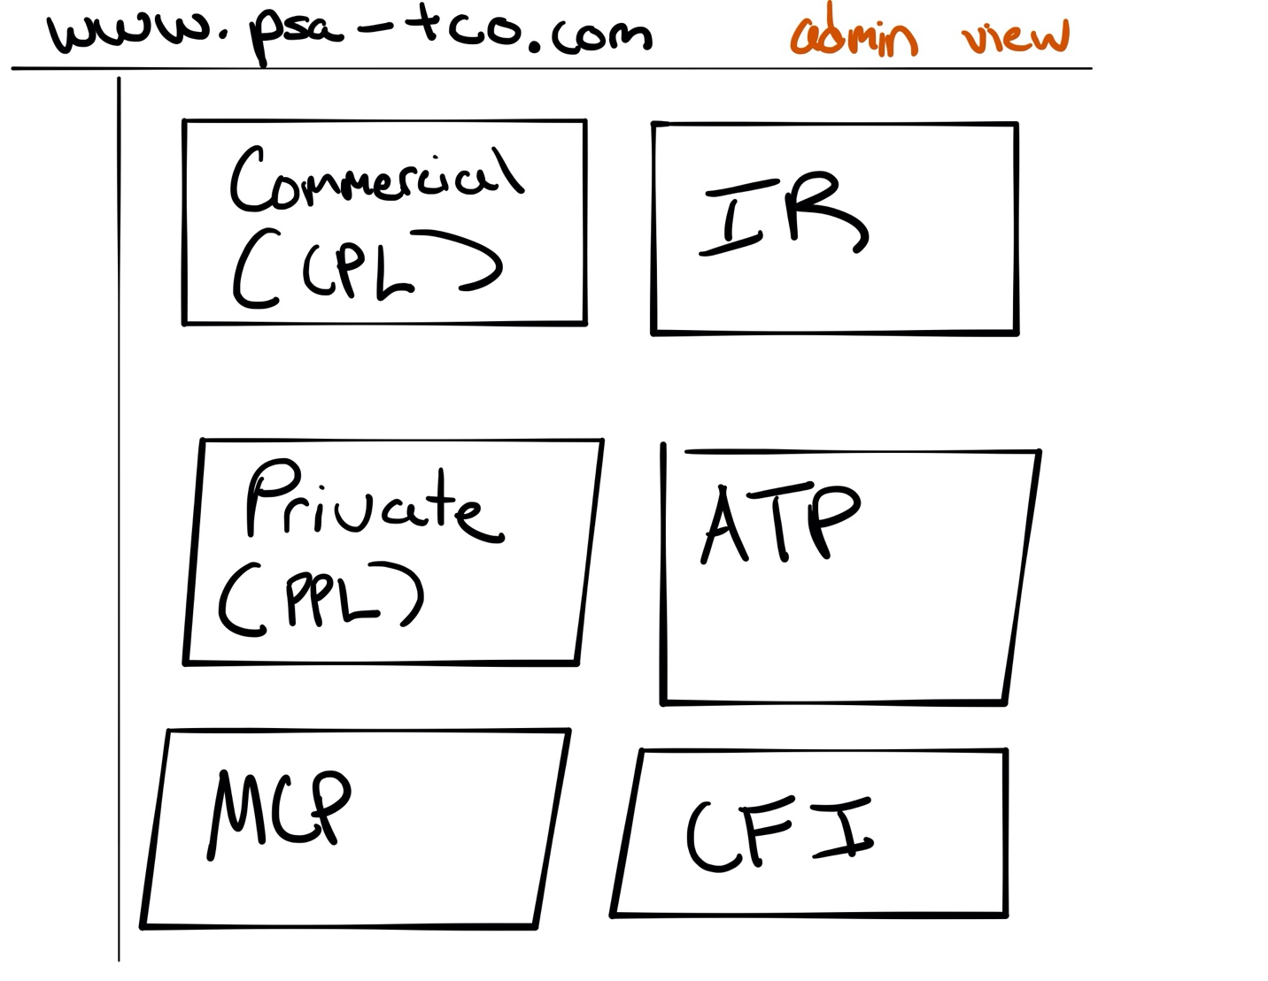

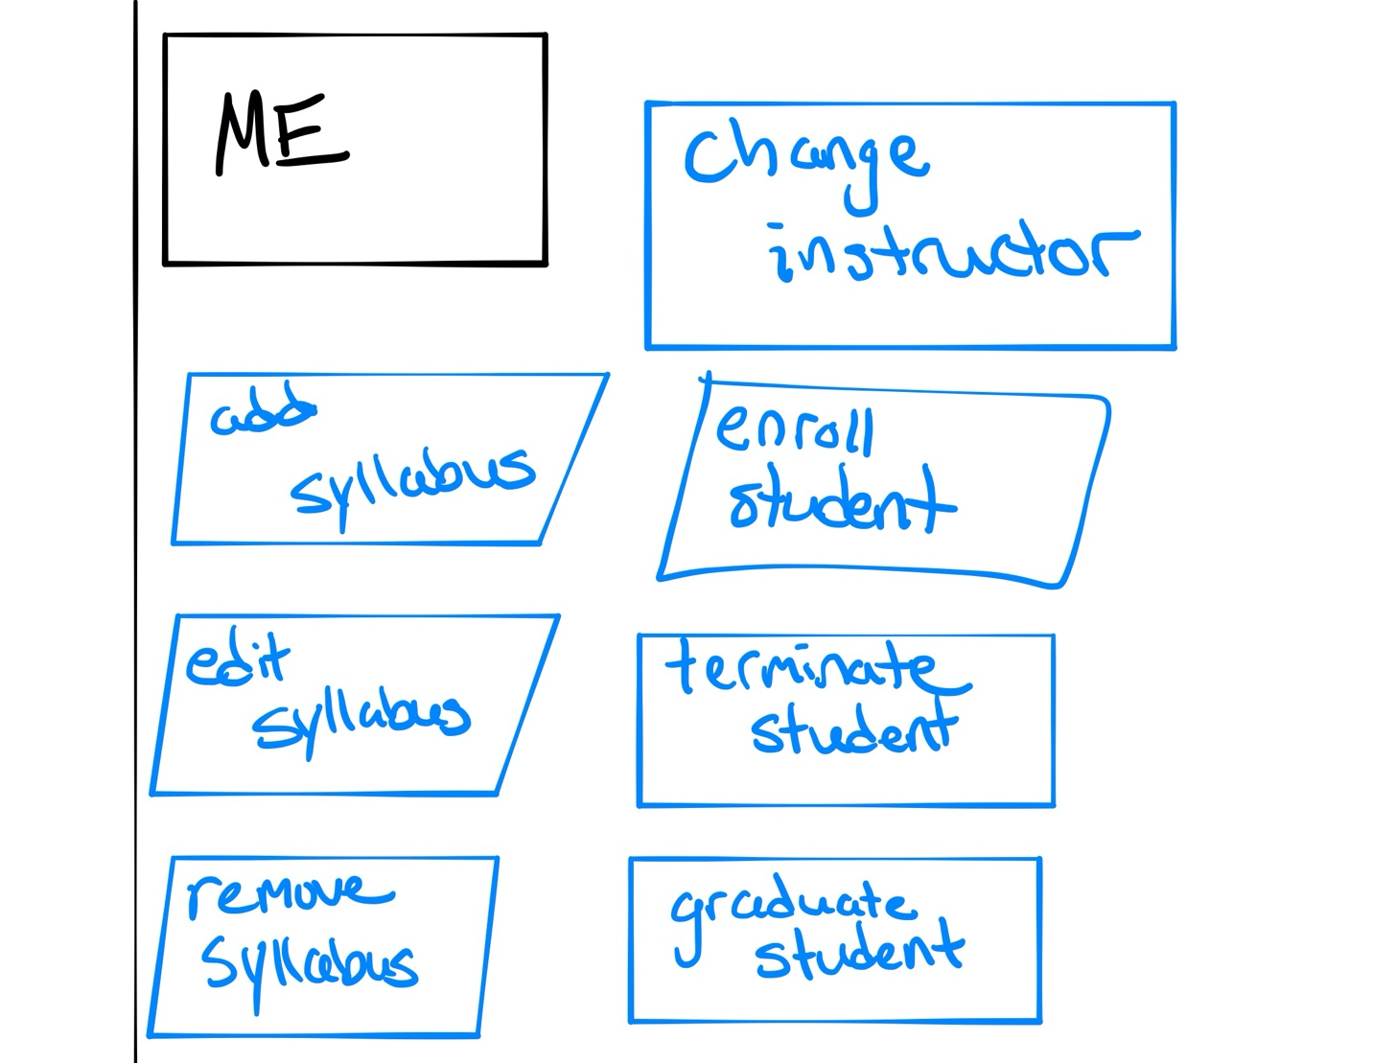

[ADMIN VIEW]

Users with administrative privileges can view any license and any student. They can do all things that students and instructors can do.

**ADMIN CONSOLE**

* Add syllabus: Add a syllabus to the existing list of syllabi.
* Edit syllabus: Change the static information of an existing syllabus.
* Remove a syllabus: Remove a syllabus and archive it in the system with date and time removed.
* Enroll a student: (See Diagram)

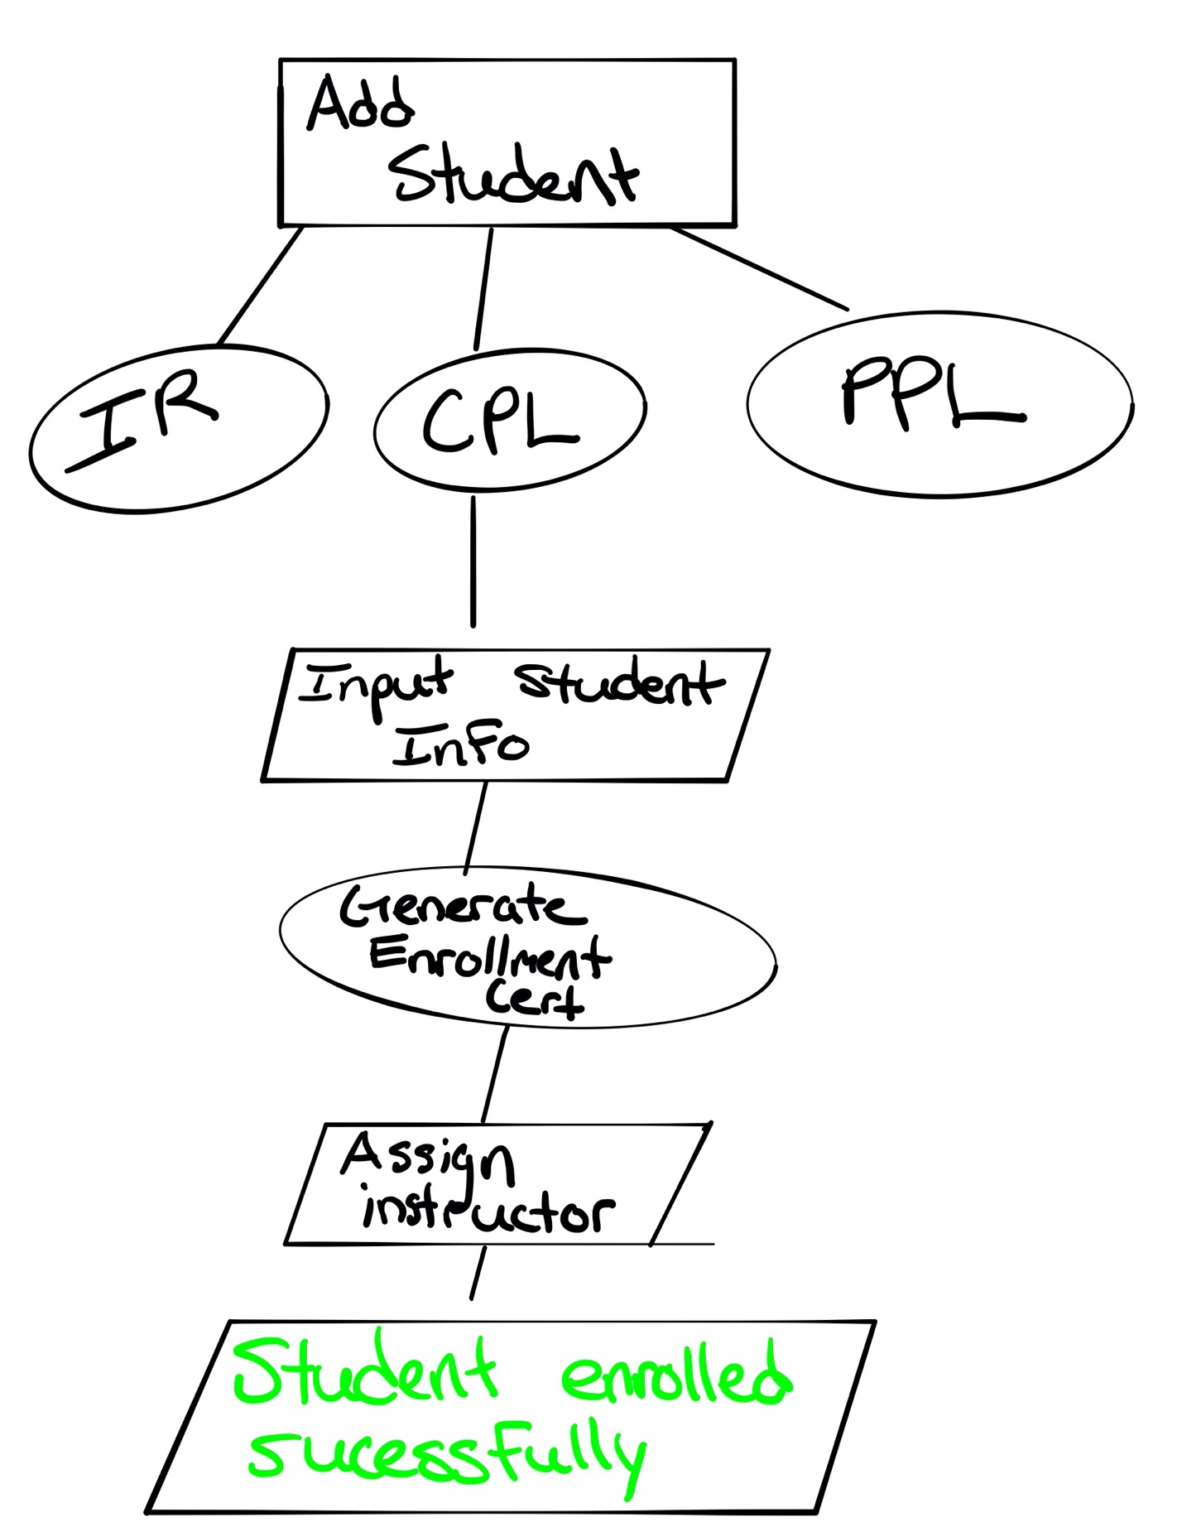

* Remove a student / Graduate (Combine): Archives a student and disables their access to their login.
* Change instructor: Specific control to change instructor for a specific student.

*Mention to Mr. Yahya to move this button to student view but for admin only. (maybe information)

**LESSON VIEW**

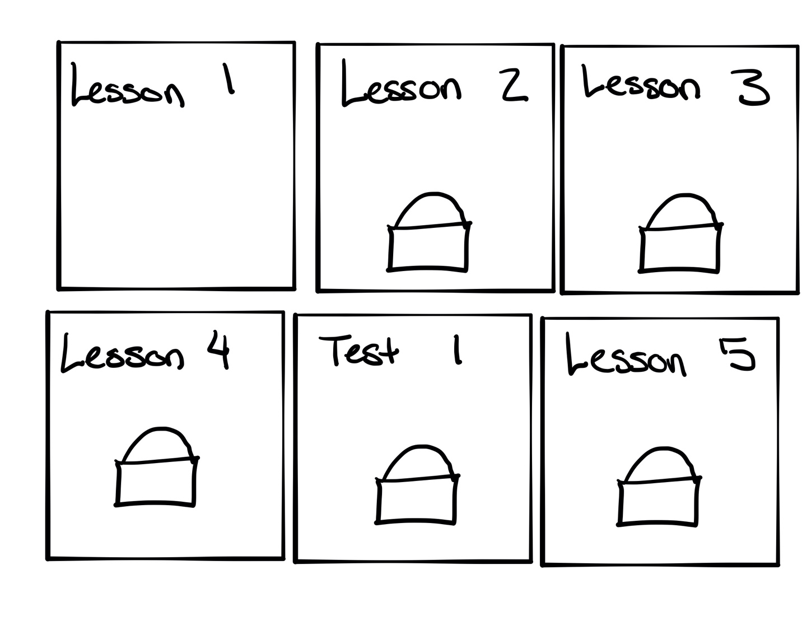

**[Lesson View]**

See all lessons and see if it is locked/unlocked.

**[Click a lesson]**

Clicking a lesson will allow you to read the lesson, (if instructor) grade the lesson, (if admin) unlock the lesson, and sign the lesson.

**[Clicking a Test]**

Clicking a test will allow you to take the test. Maximum 2 attempts and >80 to pass. 2 Versions, A & B. Only admin can reset the test for retaking.

## User Permissions:

|  |  |
| --- | --- |
| Student | * View/sign their lessons * View their certifications * View their information (phone, name, email, documents) * View chronolog |
| Instructor | * Can do what students can do but for each of their students * View their different students across different licenses * Can sign/grade student’s lessons |
| Admin | * Can do everything an instructor can do * Unlock/lock a lesson for a student * Add/remove/edit students * Add/edit/remove syallabi * Reset passwords for students / see their username/email * Change instructor for a student |

## Software Quality and Non-Functional Requirements

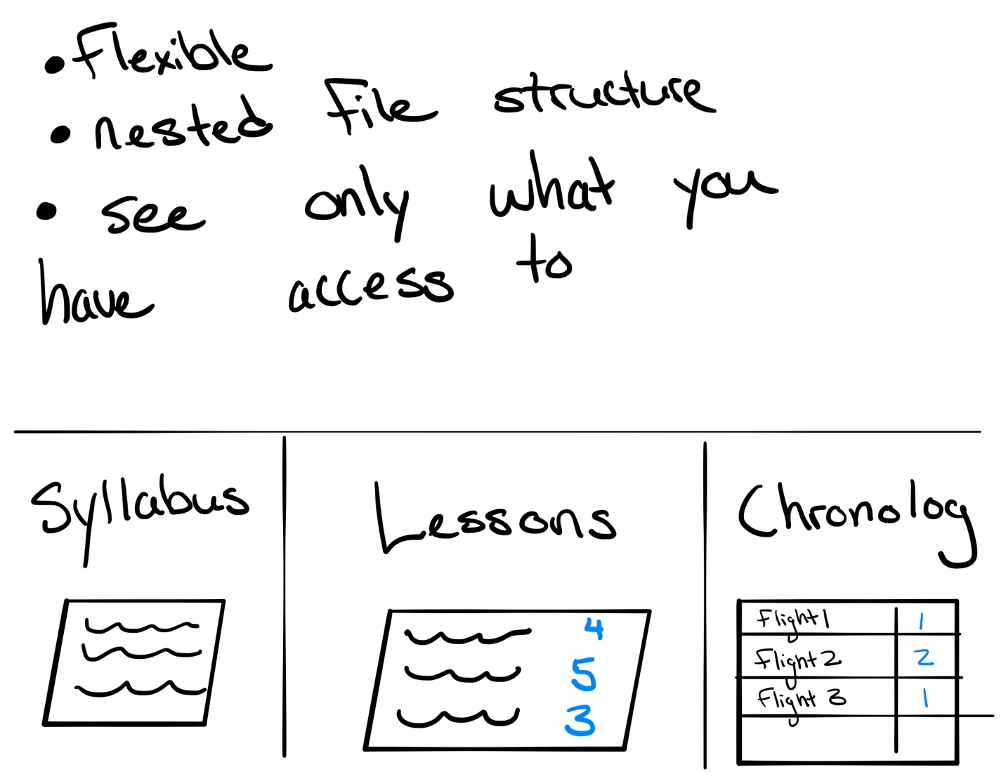

The four main key components of PSA-TCO for developers to focus on are:

* Flexibility
  + Ensure that changes made in one place are reflected in other places.
* Privacy
  + Ensure at no time any personal information is leaked or available to anymore. If passwords/usernames are forgotten, admin are able to click [Forgot Password] and the user will be able to reset their password. If forgot email, admin will have to look at a student’s information.
* Simplicity
  + Users without the specific permissions will not be able to access content that they are not allowed access to.
* Usability
  + The site must be easy for users to use and go able. Links and buttons should always be working, and the site should be easy to interact with and navigate.

## Assumptions / Risks

Assumptions:

* Audience is mainly aircraft clientele
* Assume that people have internet access and that a very popular way to access their lessons are online
* Assume that people are accessing this information from any part of the globe and are able to speak English.
* Formalize and streamline process of providing access to PSA syllabus information.

Risks:

* One developer (Slow bug fixes/ development time)
* Adding a student must go through the student intake process, no (Create an account button)
* Hopefully deliver by September

## Deployment Plan

PSA instructors and students will be trained on how to use the system and its implementations for 6 weeks. The transition to the web application from the traditional handwriting method of current will be facilitated by this training process. Users will be provided general documented instructions on PSA-TCO’s home website with how to get in contact with help. All users will be added by system admins. The web application is planned to release in September of 2020.

## Privacy

Customer information and data on the PSA-TCO app will be handled with extreme caution and care. PSA will be inputting names, emails, and phone numbers. With that being said, the data servers need to be encrypted and backed up. Only PSA users can access their information provided that their account has been authenticated and authorized. PSA will preserve and protect customer data and will never attempt to misuse the data in any type of way. This includes but is not limited to selling or distributing data to other third parties for any reason. User privacy is one of the core values of the application.

## Open Issues

[To be determined]

Privacy:

Privacy is controversial because either side, client or business, can interpret the use of data in different ways. For example, a company can be distributing or sharing data with a partner or sister company, but the user can see that as a way of impeaching on the user’s right to privacy by companies sharing data.

Language Support:

Currently, Hooli Help has plans of opening originally in the US but only has plans of originally supporting Spanish or English-speaking customers. For the future, Hooli Help will need to support other languages in order to maintain itself as a global company.

Scalability:  
With an ever-growing need of more servers for more users, Hooli will have to be constantly adapting to the demand of its web application in terms of scale. Outsourcing servers to companies like AWS or Google Cloud or Microsoft Azure are possibilities here.

Wait Times:

How long should a client wait to be connected to a client? What is the maximum amount of time a customer should wait in the queue? What if the support app is always busy? How long is too long? Can customers leave their name and contact info to receive a callback? Can users schedule a call? These are all questions to be asked with the ever-growing demand and need for a customer support system.

Surveys:

Users should be able to provide feedback and input for the application. How that feedback is interpreted is controversial because of the bias in the company’s favor because of how thereted. The

y can either take the feedback or leave it.

For developer:

HOST: HEROKU

DOMAIN: GOOGLE DOMAINS

FRONT END: REACT

DB: POSTGRESQL

BACKEND: DJANGO

[END]